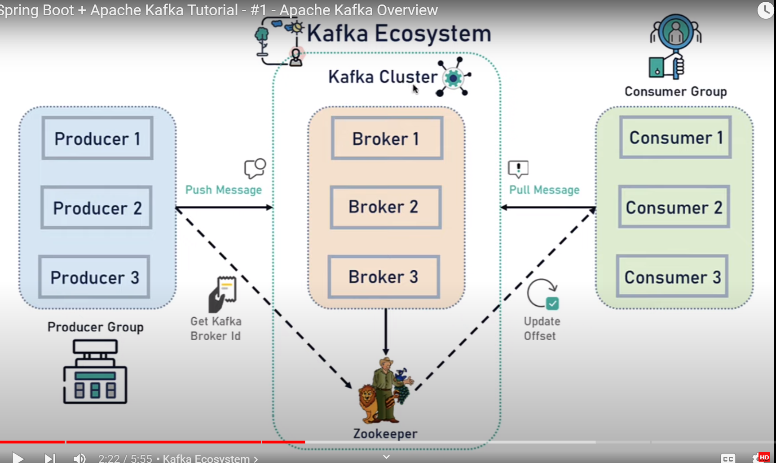

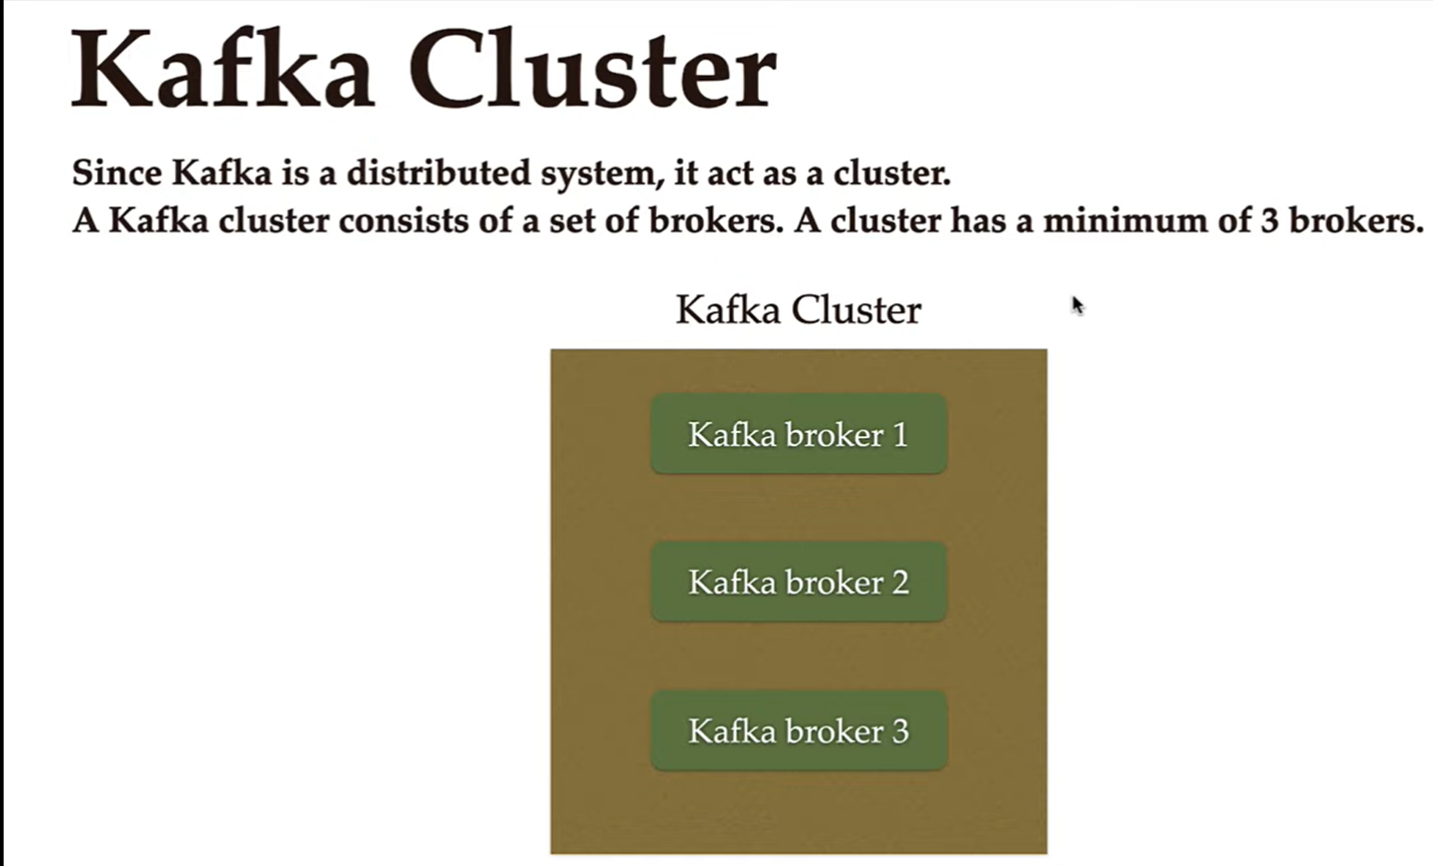

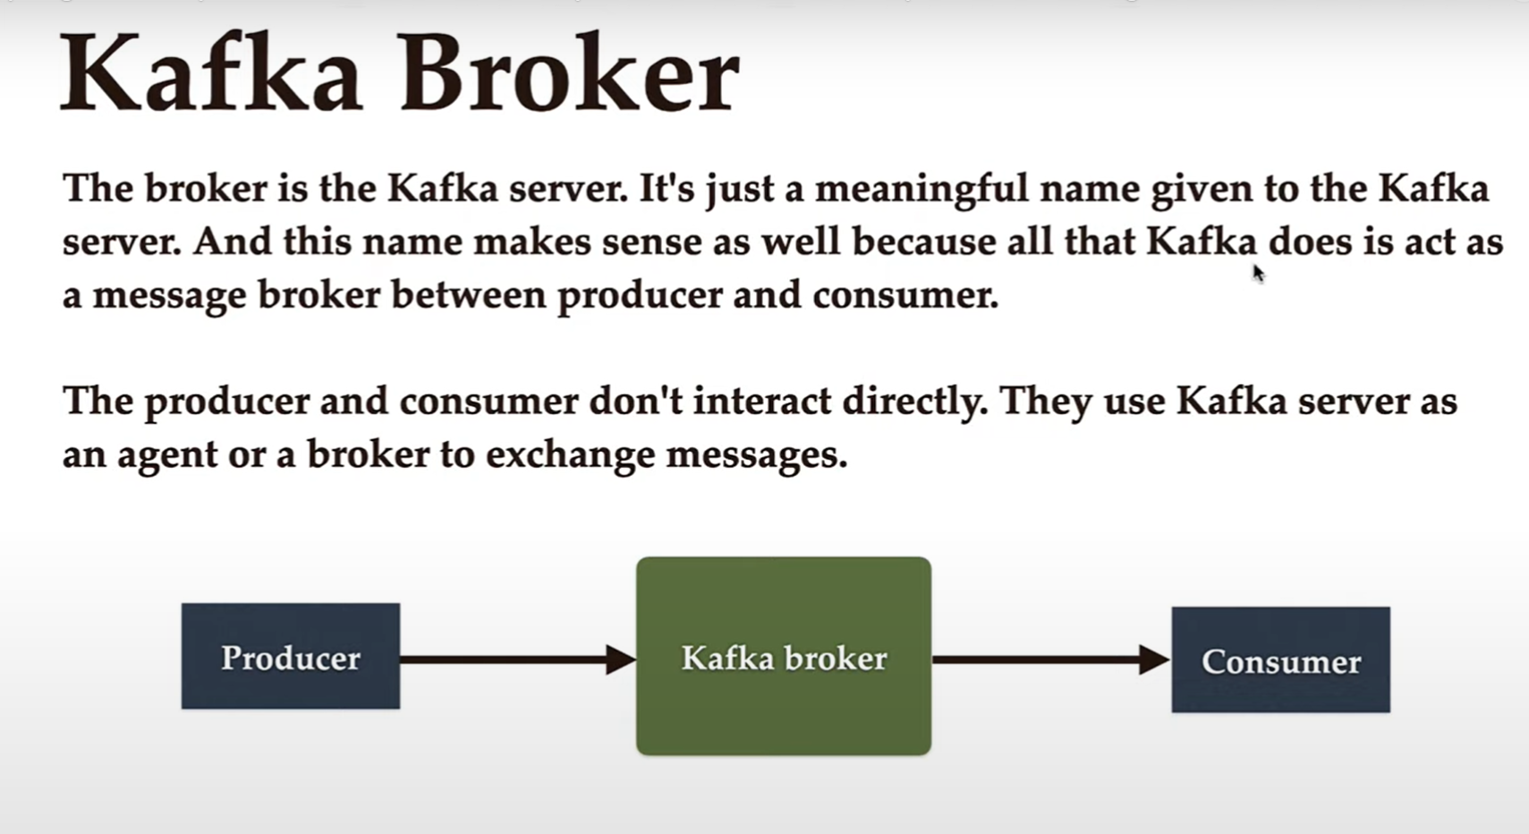

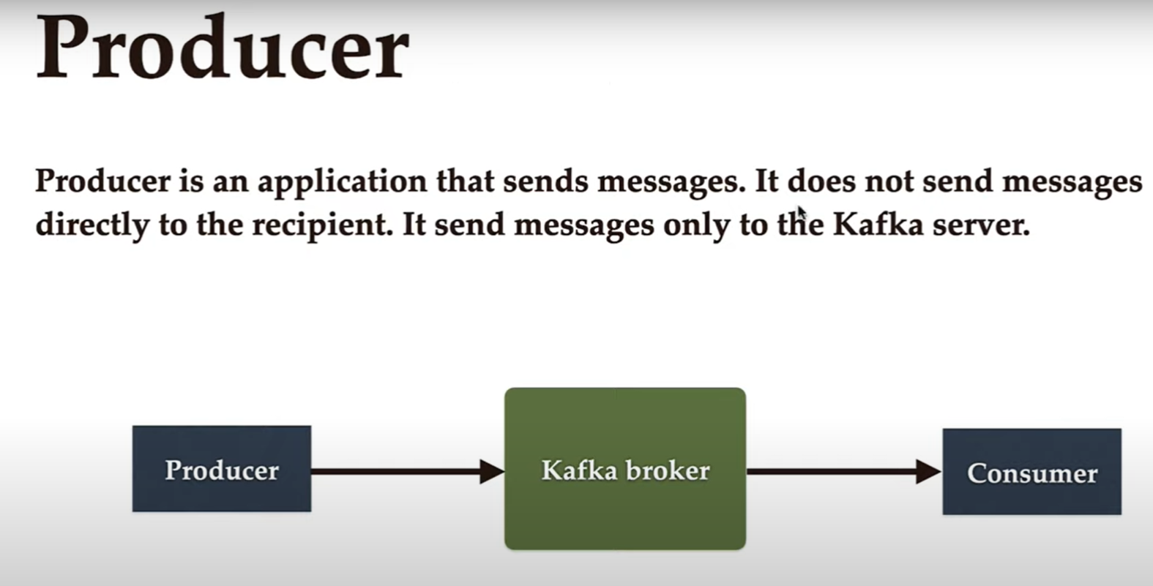

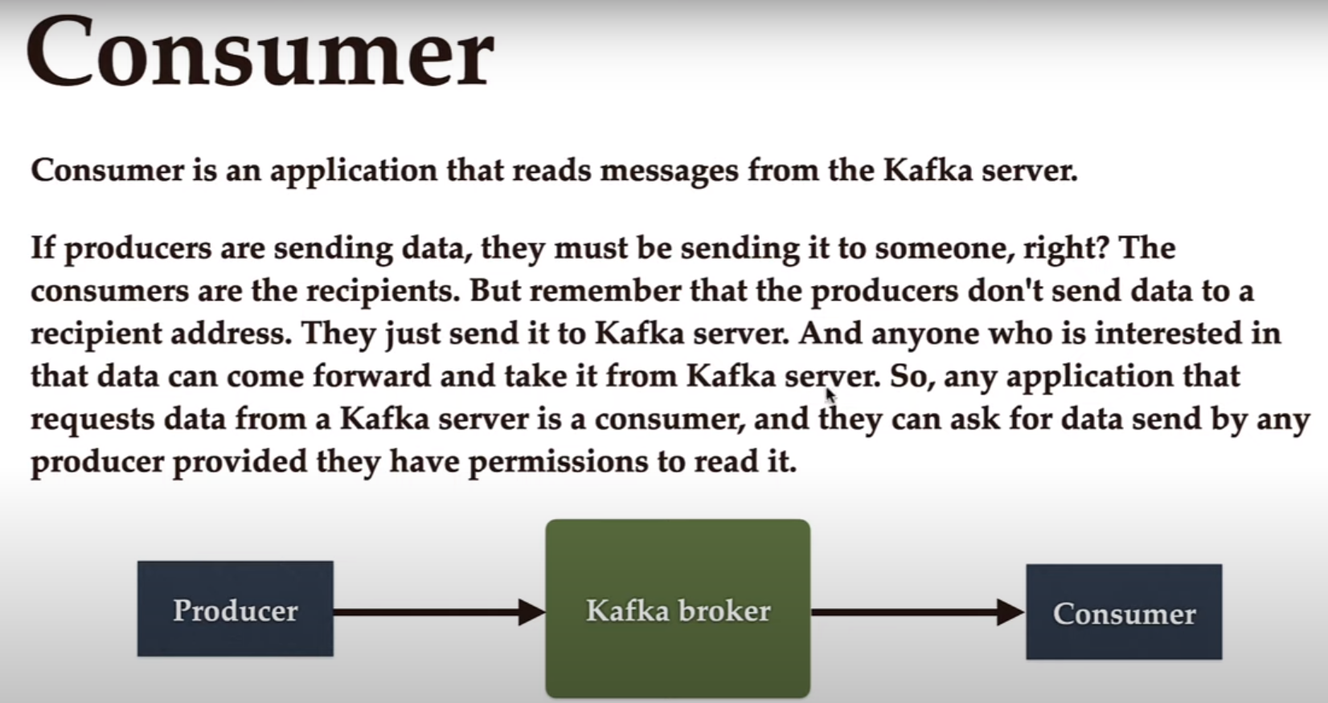

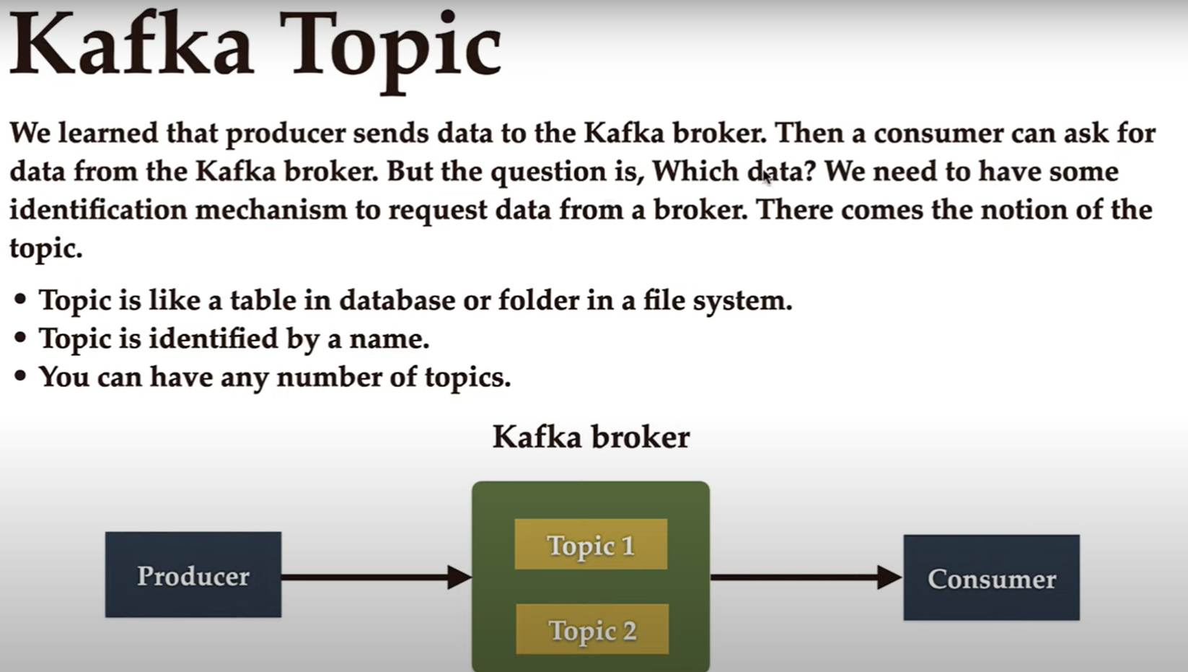

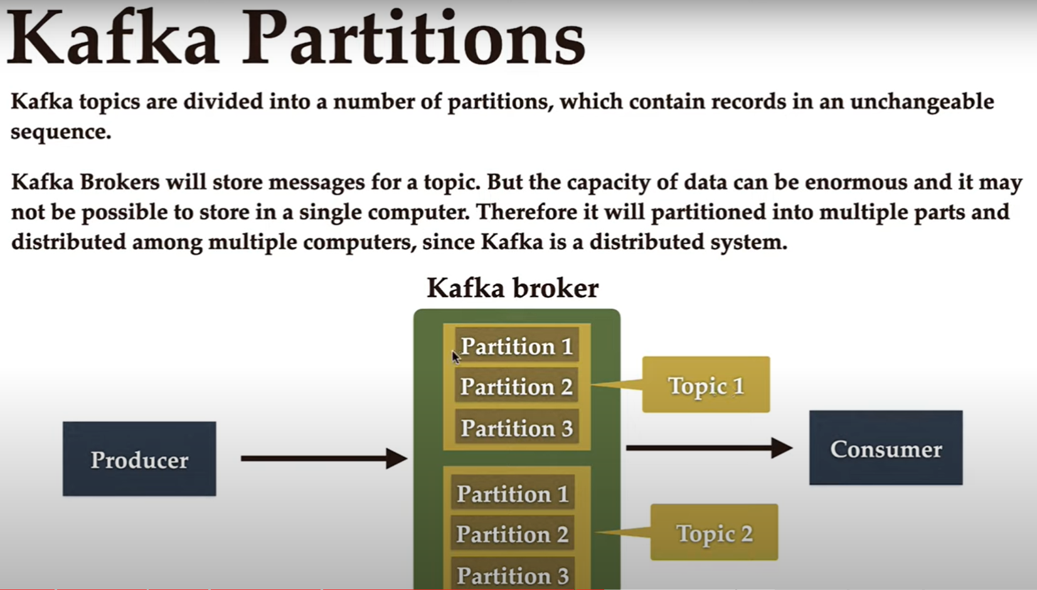

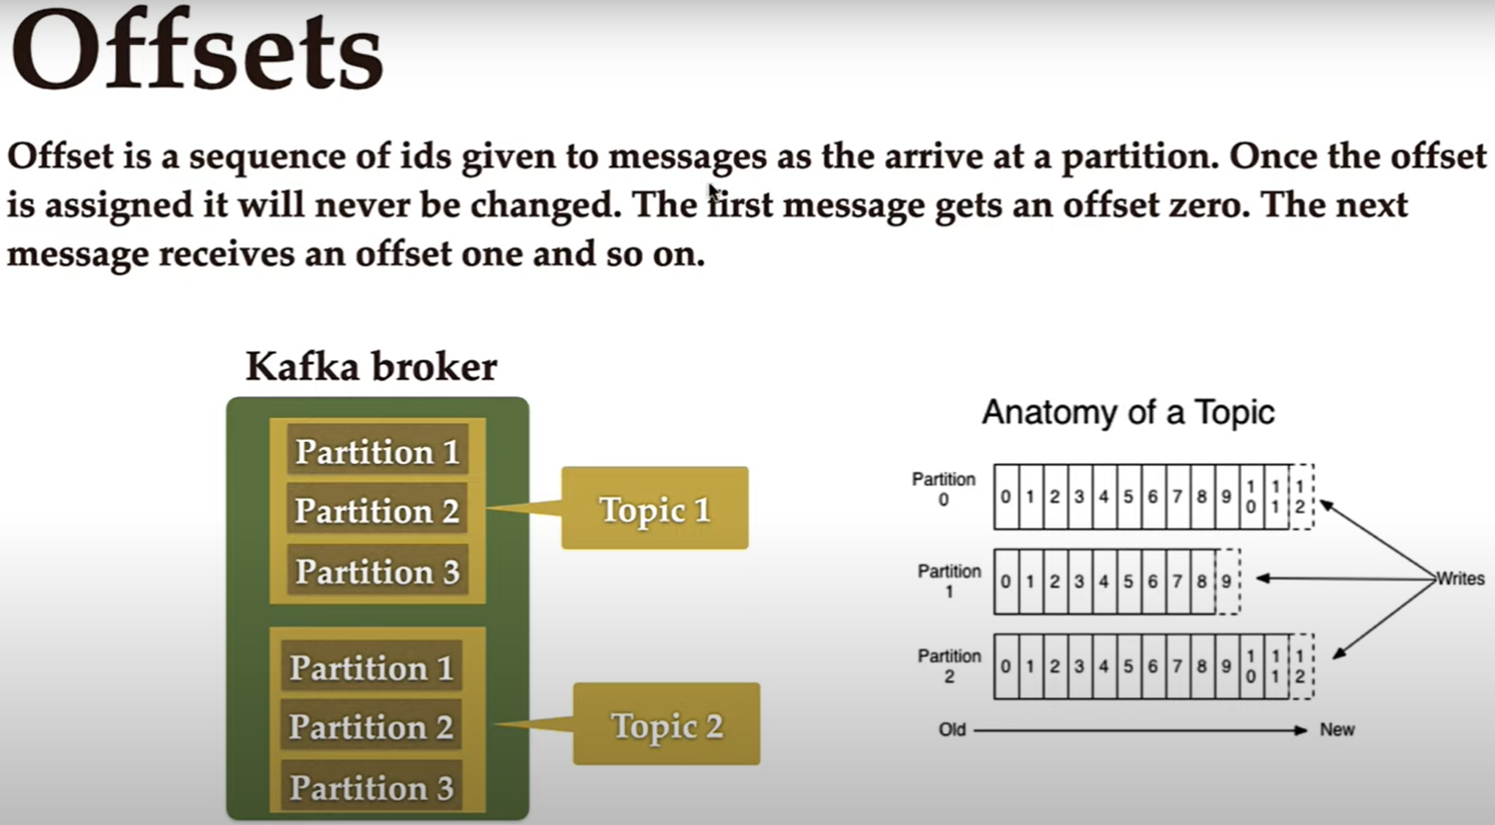

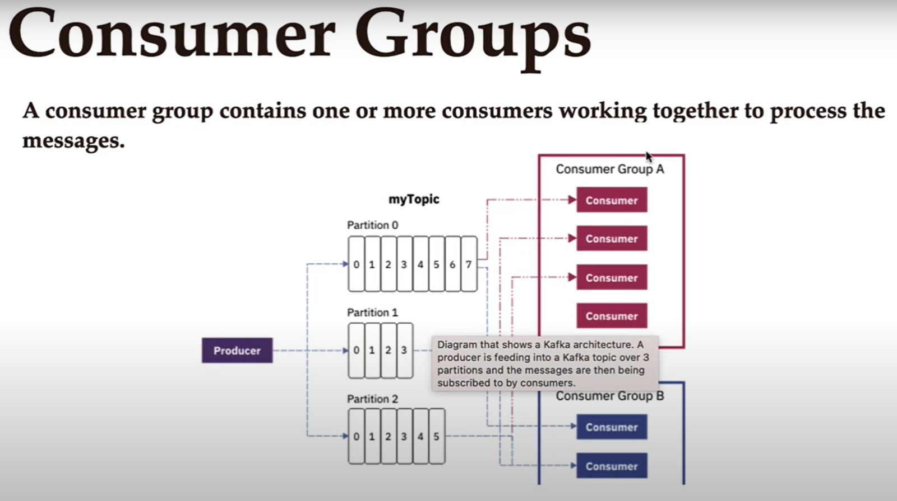

To start a Kafka environment on Windows using the command line, you'll need to follow these steps:

1. Download Kafka:
   * Go to the Apache Kafka website: <https://kafka.apache.org/downloads>
   * Download the latest stable version of Kafka for Windows.
   * Extract the downloaded archive to a location of your choice, e.g., **C:\kafka**.
2. Start ZooKeeper server: Kafka relies on ZooKeeper, so you need to start ZooKeeper first.
   * Open a command prompt (CMD) as an administrator.
   * Navigate to the Kafka installation directory:

cd C:\kafka

Start ZooKeeper by running the following command:

bin\windows\zookeeper-server-start.bat config\zookeeper.properties

Start Kafka server: With ZooKeeper running, you can now start the Kafka server.

* Open another command prompt as an administrator.
* Navigate to the Kafka installation directory if you are not already there.
* Start Kafka by running the following command:

bin\windows\kafka-server-start.bat config\server.properties

Verify Kafka is running:

* To verify that Kafka is running correctly, you can create a test topic and produce/consume messages.
* Create a test topic (for example, "test-topic"):

bin\windows\kafka-topics.bat --create --topic test-topic-json --bootstrap-server localhost:9092 --replication-factor 1 --partitions 1

Produce a test message:

bin\windows\kafka-console-producer.bat --topic test-topic --bootstrap-server localhost:9092

Consume the test message:

bin\windows\kafka-console-consumer.bat --topic test-topic-json --from-beginning --bootstrap-server localhost:9092

